WORLD HEALING DAY

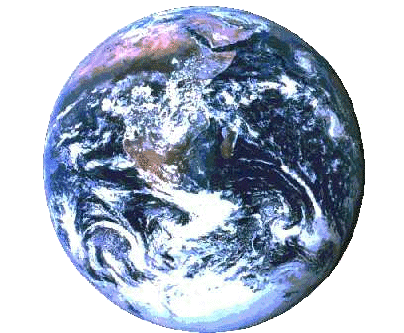
WEDNESDAY 10 SEPTEMBER 2003

A global linkup to raise world consciousness
and promote world healing

You are invited to participate in a global event to help further the awakening of planetary consciousness. This is a day for people across the world to unite in spirit and hold a collective vision of universal love and peace, a day for raising our consciousness, and increasing our healing and self-realisation.

Please observe the day in a way that is meaningful to you. Suggestions include journeying to places of beauty and power to connect with the Earth, and gathering at local parks, beaches, or town centres, or at an event dedicated to the theme of the day, such as a peace concert, a seminar, a forum, religious service, or a celebration. You can also honour the day on your own in your own space. Whatever you do, dedicate your intention to the expansion of love and awareness on the Planet, so that healing may occur. Experience your connection with all, and as you do, sense the ripples of what you are doing spreading outwards to uplift all.

Simultaneous worldwide meditations will take place at 12 noon GMT (1pm in the UK) and 16.30 GMT (5.30pm in the UK). Each meditation linkup will last for at least 20 minutes, and will consist of clear and focused positive thought. During this time, keep in your mind and heart a vision of a world in which all live in peace, harmony, and joy. See conflict and suffering being replaced with compassion, forgiveness, and awareness in all areas of life. Visualise light spreading across the Planet as world consciousness is raised.

Leaflets, further information, and a special music CD are available. If you would like to receive any of these or be connected up with others in your area, please let us know, or visit the website. For inland replies please enclose an SAE. Donations of any amount will be gratefully received (payable to ‘World Healing Project’) and will help to finance the project.

Please photocopy, display, and network this leaflet!

World Healing Day  c/o Leigh Tremaine  21 The Glade  Birmingham B26 3PW  UK | Tel / Fax: (+44) (0)121 742 8575  Website: www.worldhealing.co.uk/whd  May Peace Prevail on Earth

